**Globalshala Virtual Internship Project**

**WEEK 2**

-**GROUP 9**

**Description:**

**Data set**: Marketing Team Campaign Data

**Number of rows:** 34

**Number of Columns:** 21

**Objective:**

To analyze the visualization of different campaign ID with different fields.

**Analysis:**

Graph demonstrating different scenarios based on the Campaign are demonstrated below:

**Graph 1: Campaign Cost**

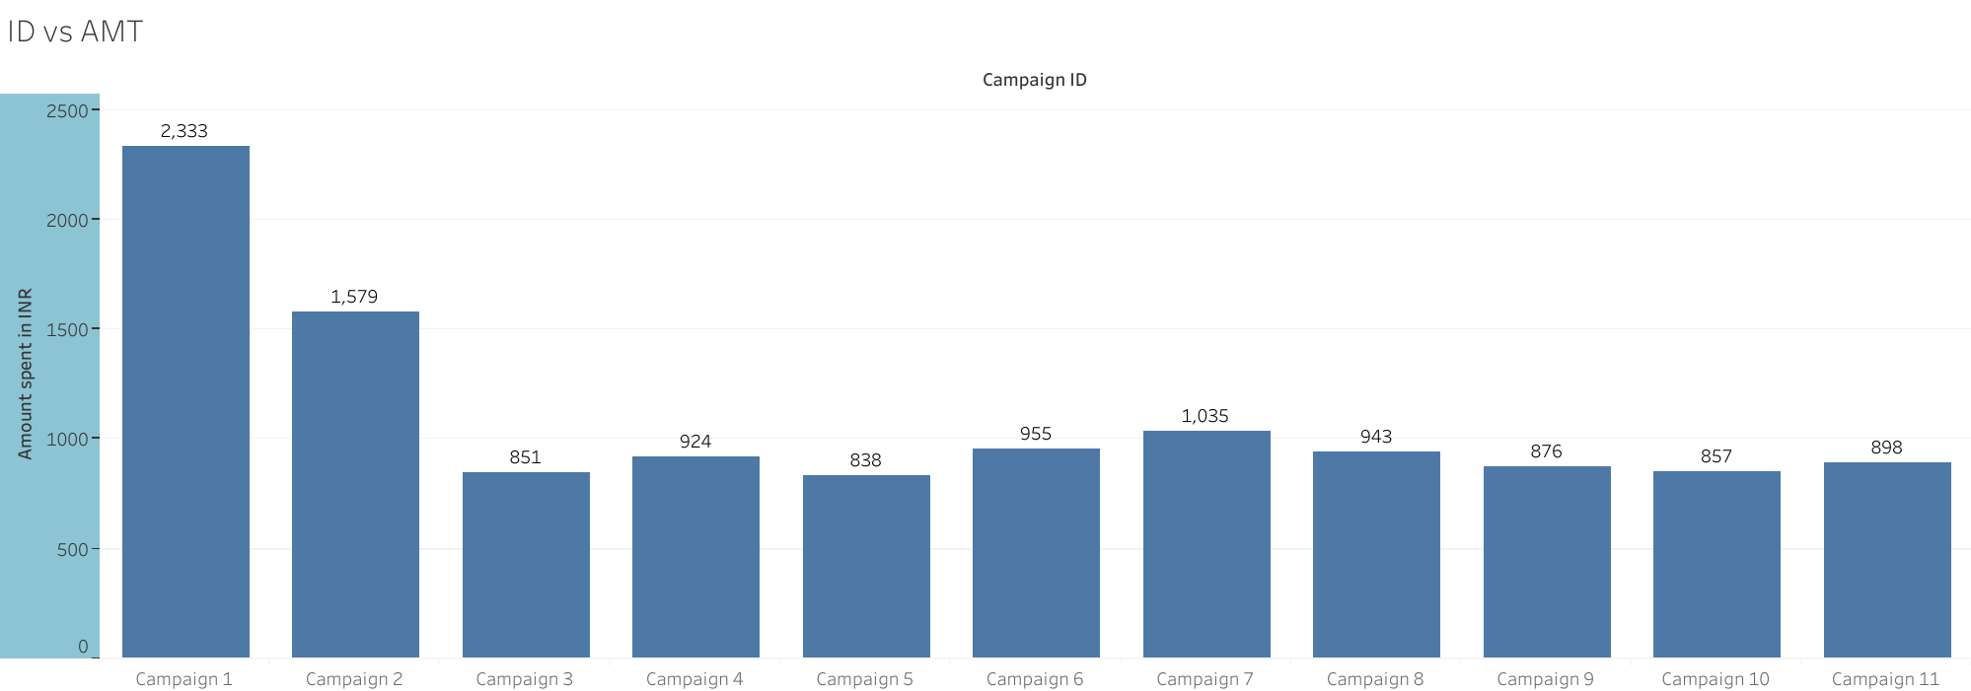

In the above graph, campaign 5 has lowest spending amount in INR at 837.78, followed by campaign 3, 10 and so on. Campaign 1 accounted for 19.30% of amount spent in INR which amounted to 2,333.33 INR.

**Graph 2: Reach of each Campaign**

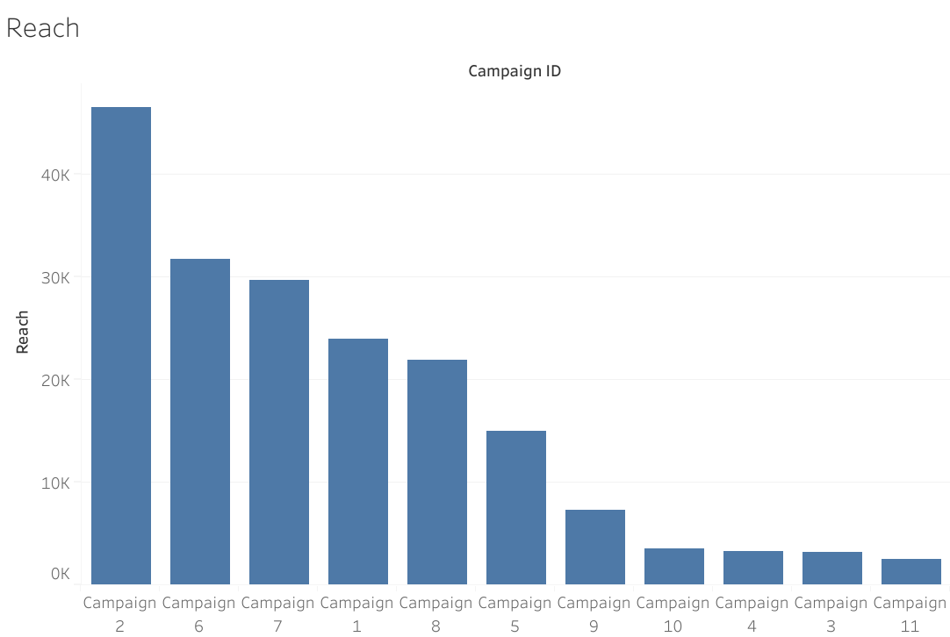

From the above graph, it is concluded that Campaign 2 had highest Reach at 46494 and campaign 11 has the lowest at 2555. So, Campaign 2 is 1719.73% higher than Campaign 11. Campaign 2 has second highest and accounted for 24.64% of Reach.

**Graph 3: Reach and Impressions**

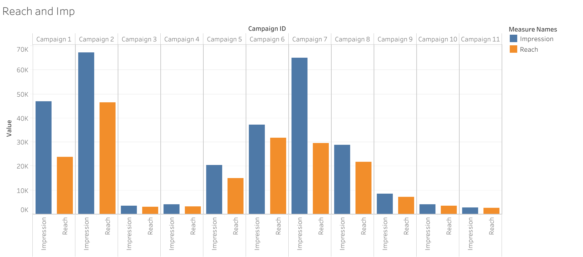

From the above Reach vs. impressions graph, it is seen that Campaign 2 has the highest reach at 46494 and campaign 11 has the lowest reach at 2555. Also, Campaign 2 is 1719.73% higher than Campaign 11.

Here, Reach and Impressions are positively correlated with each other. Reach and Impressions diverged the most when the campaign ID was Campaign 7, when impressions were 35547 higher than Reach.

**Graph 4: Individual campaigns reach every age Group**

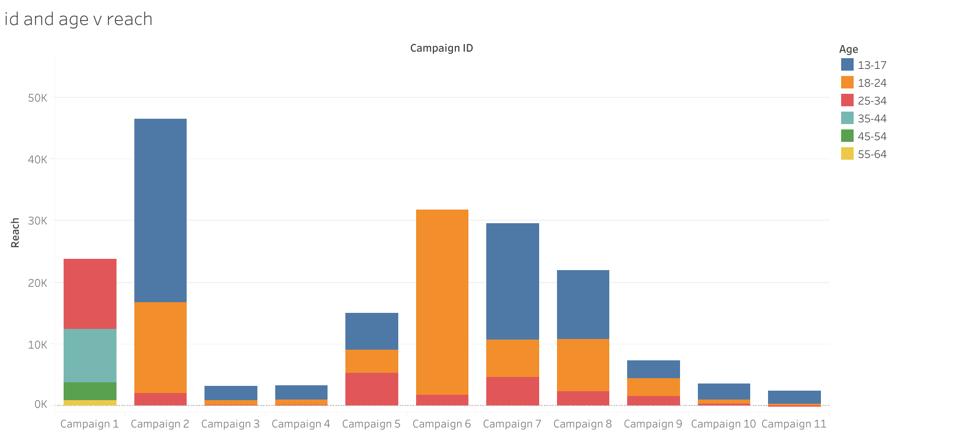

In this above graph Reach is distributed as per the age group within each campaign. In the above Graph, Age group 18-24 within the Campaign made 15.94% of reach.

**Graph 5: Amount Spent for every Campaign Location (Geography)**

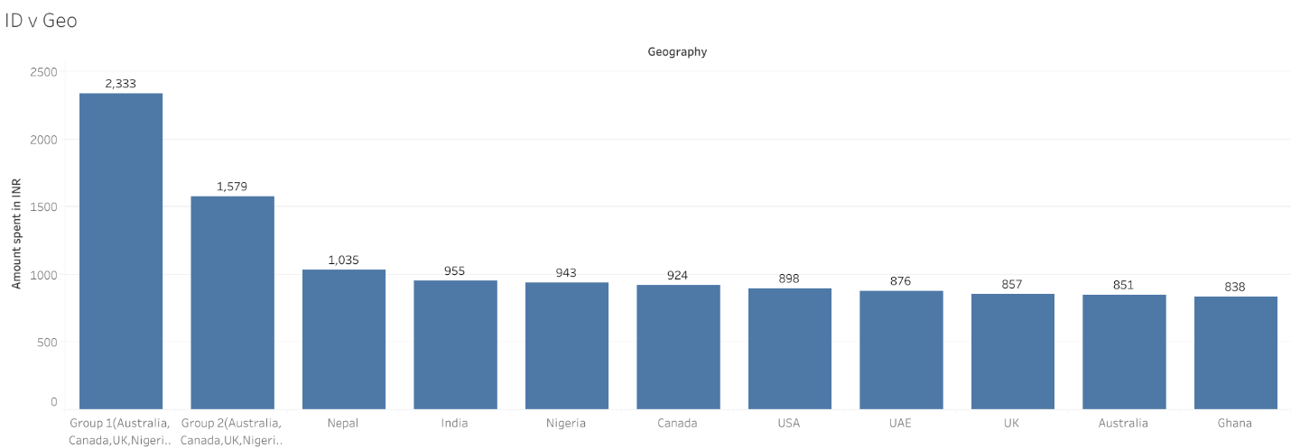

Above graph shows the Amount spent based on the Geography. It is demonstrated that Group 1(Australia. Canada, UK, Ghana, Nigeria, Pakistan, and United States) spent Highest Amount in INR at 2333.33 and lowest spent in INR was done by Ghana at 837.78. Group 1 accounted for 19.30% of Amount spent in INR.